**Start building the Big Data Analysis solutions using IBM cloud databases**

**Step 1: Create an account in the IBM cloud.**

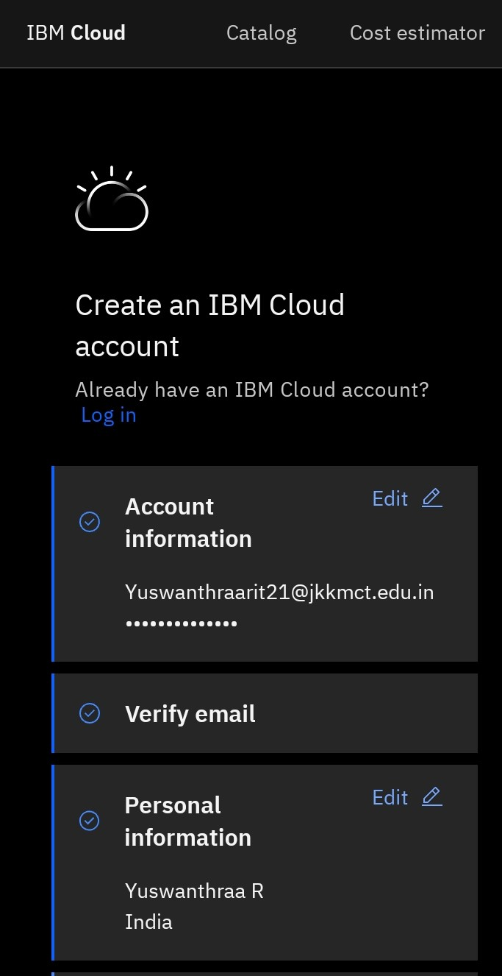

**STEP 2: Accept all the conditions and continue to create an account.**

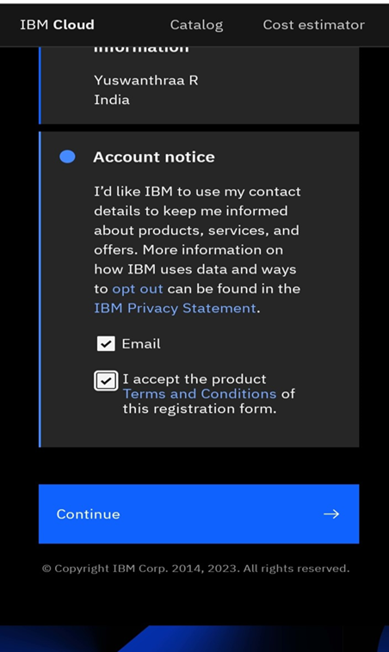

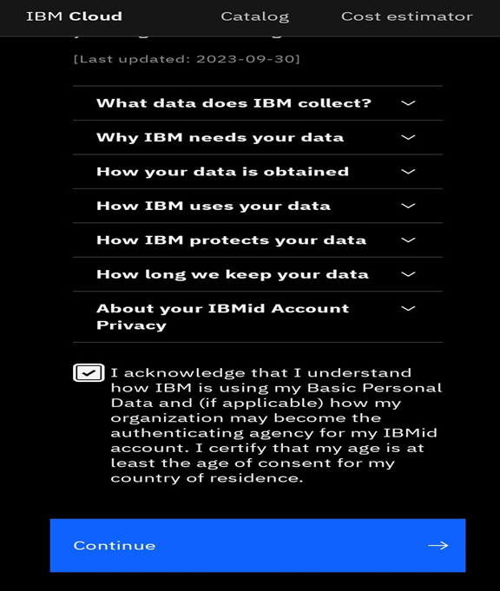

**STEP 3: Using mail ID and password to open the IBM cloud.**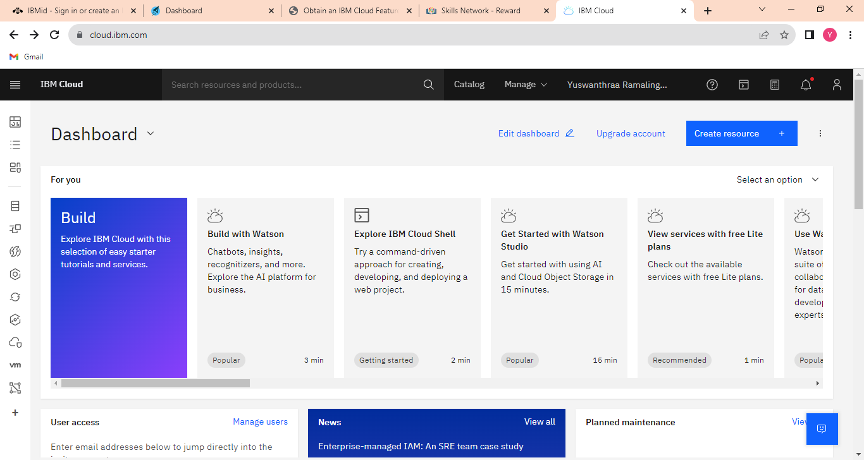

**STEP 4: Click the (Browse the service)**

**To open it. Hence, the catalog page will open here.**

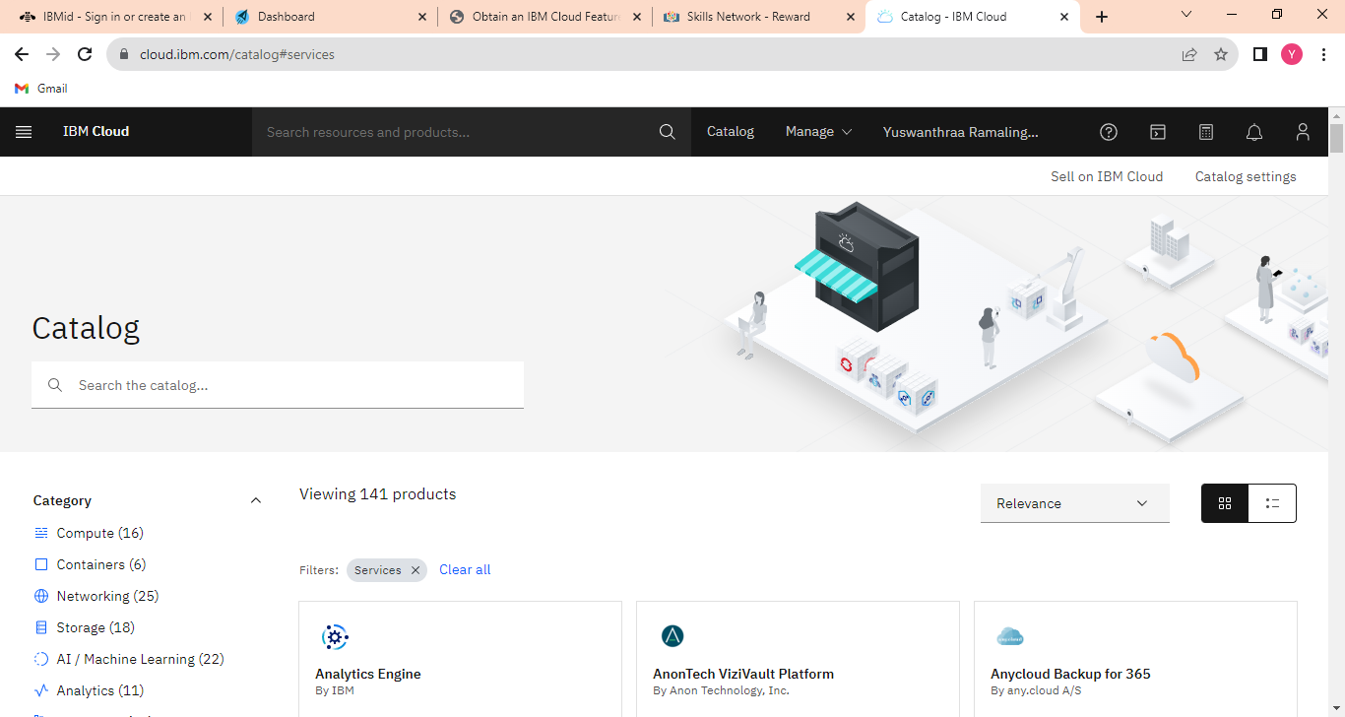

**Choose any database in the catalog.**

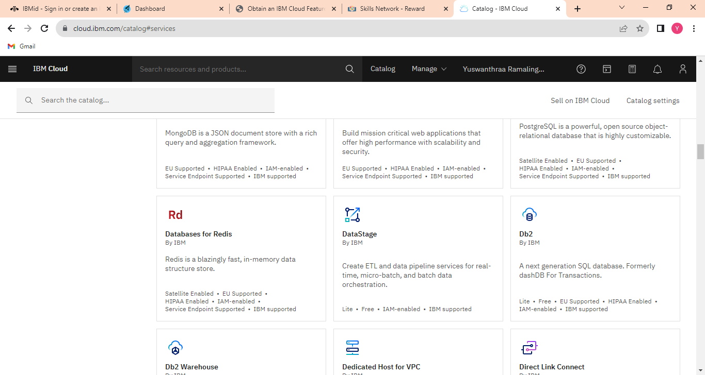

**STEP 5: I choose a Db2 database in this catalog.**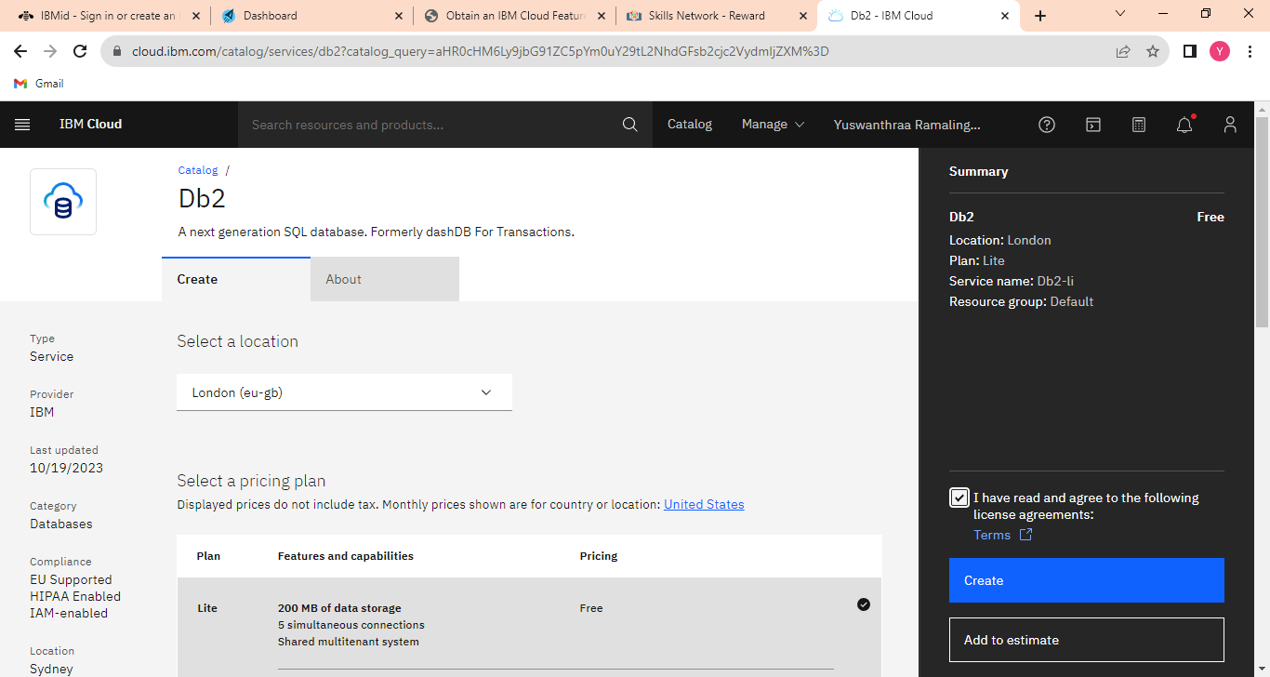

**In this Db2 the location was changed to London(eu-gb).**

**Click the lite.**

**Accept the terms.**

**Create the database instance.**

**STEP 6: Click the resource list to active the Db2.** 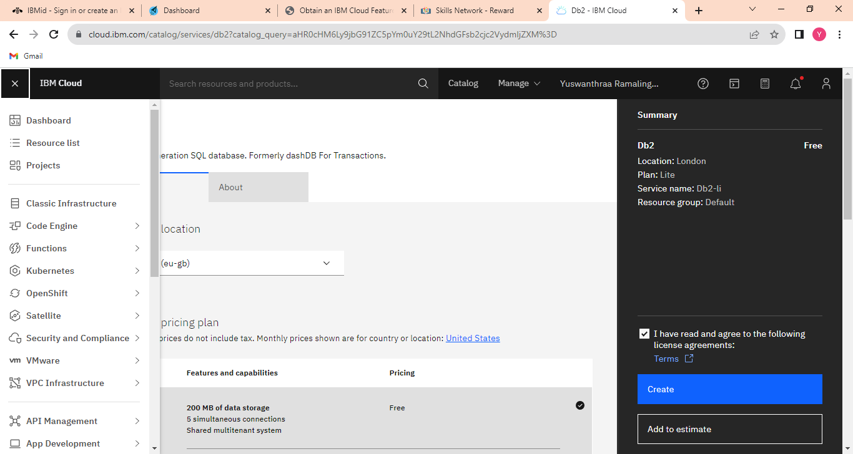

**On this page click the resource list to activate the instance database.**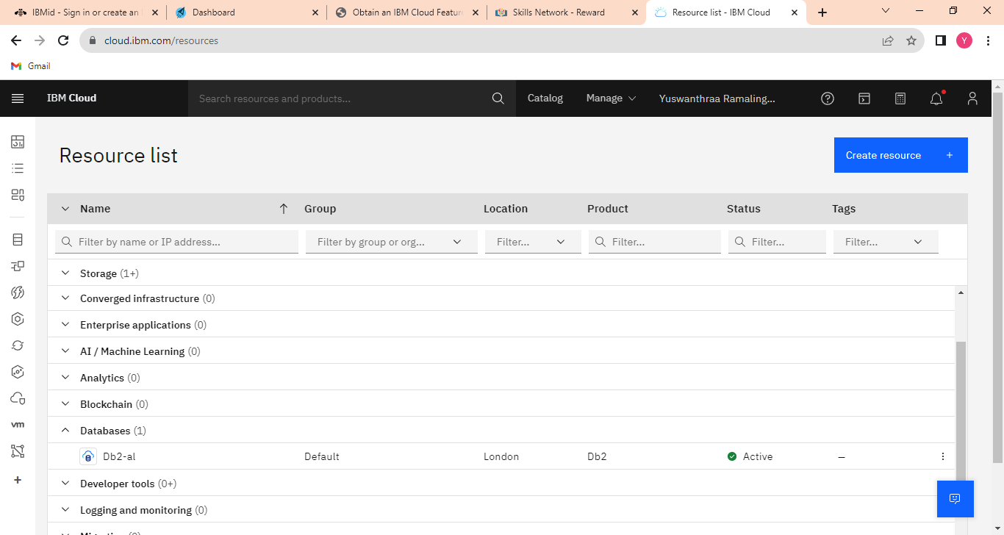

**STEP 7: In this Db2 there are 4 options (manage, getting started, service credentials, connections).**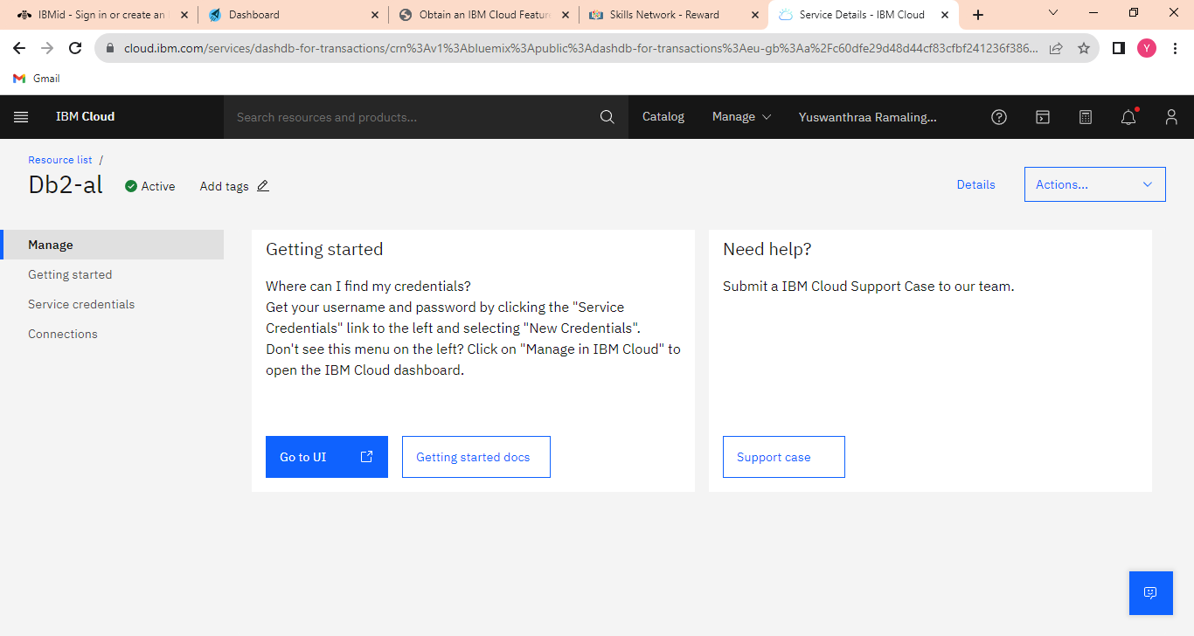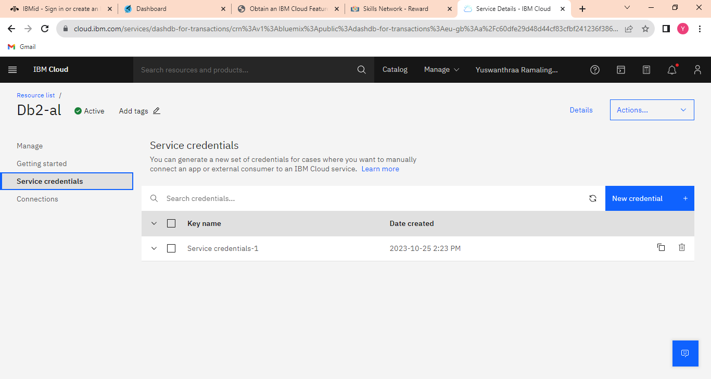

**Click the service credentials (service credentials-1) is already created what to create means click the new credentials.**

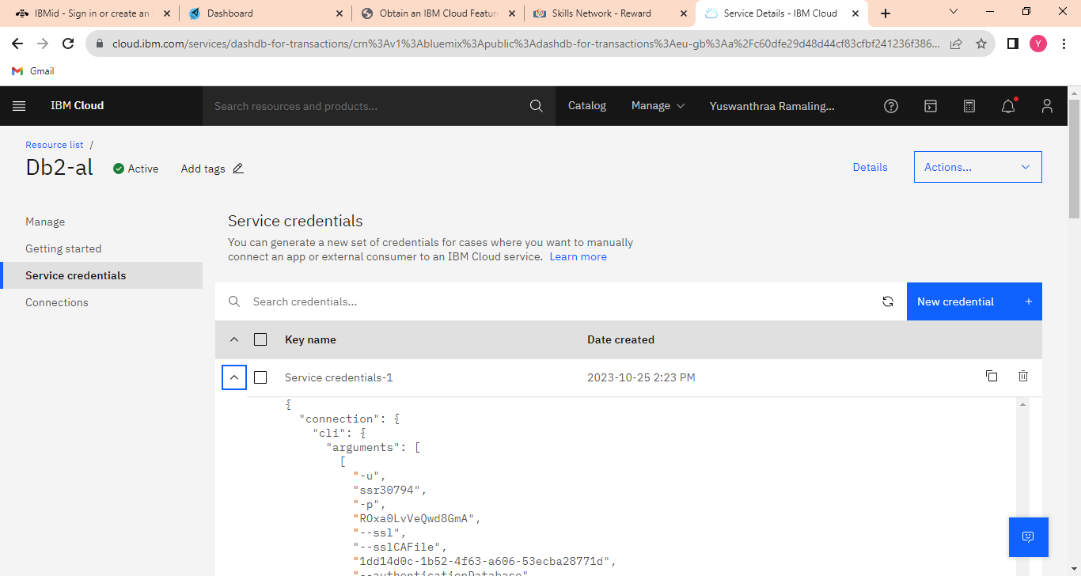

**In this (service credentials -1) having a query like a dataset. Click the manage option.**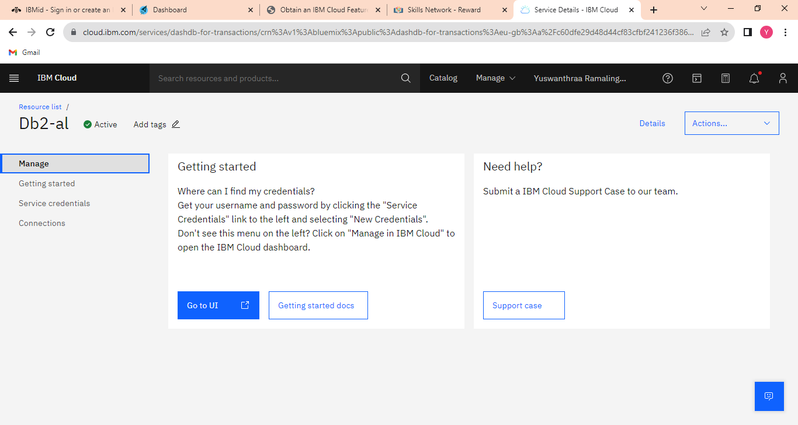

**STEP 8: In this manage option click the (go to UI). It will open the IBM Db2 on the cloud page.**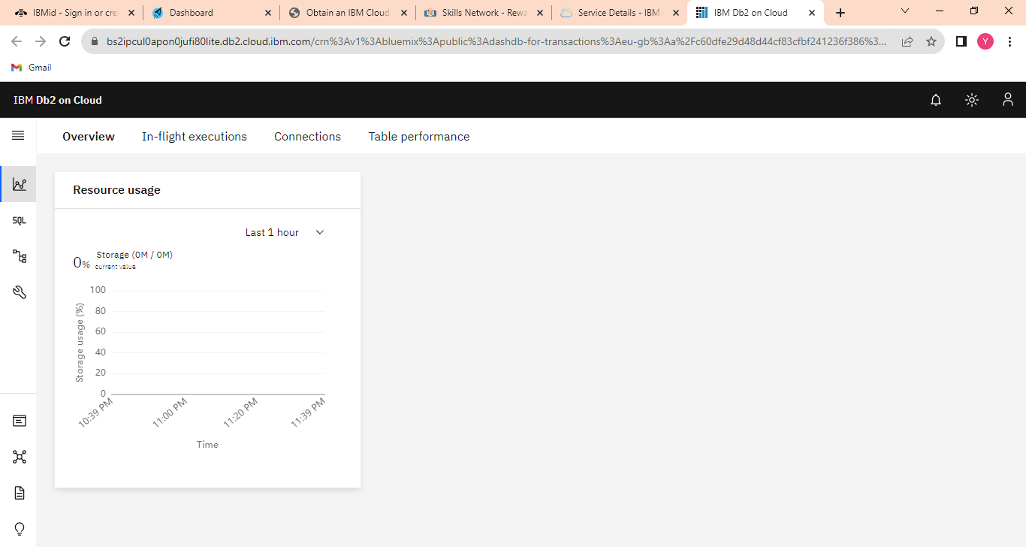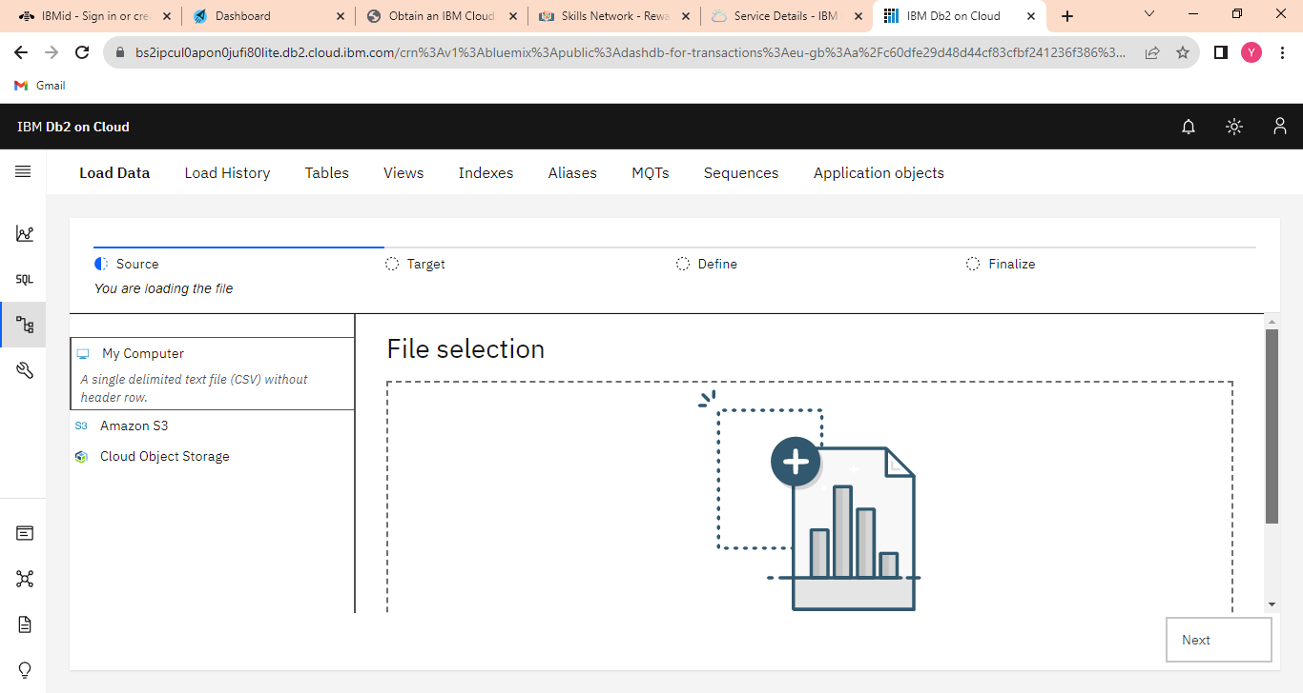

**In this file selection, we need to upload the dataset that we downloaded in the browser. I uploaded the healthcare-related dataset(HeartAttackDataset.csv)the uploading file must be in csv or TXT otherwise it will be in a zip file means it will not upload.**

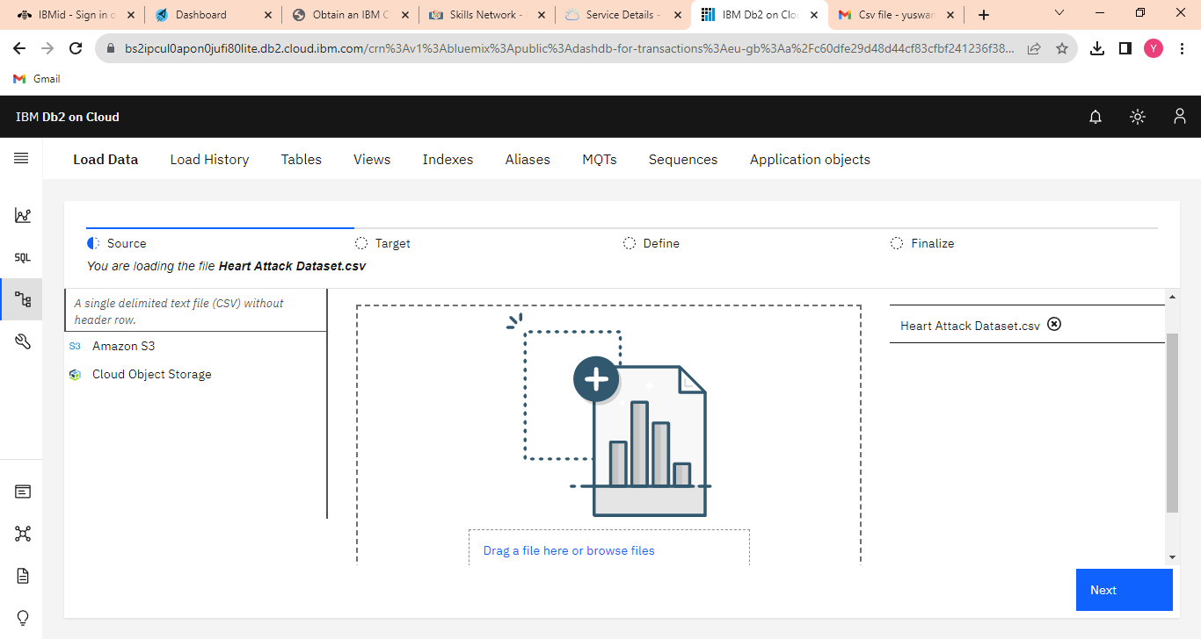

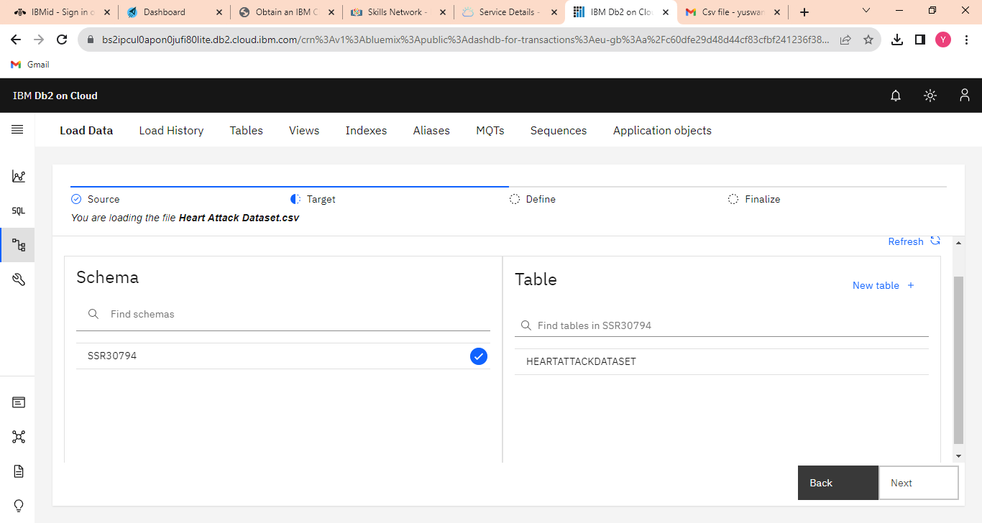

**Click the next to open the schema and the table is already created here if need to create the table, click the new table. Click the dataset of (HeartAttackDataset.csv) to show the table definition.**

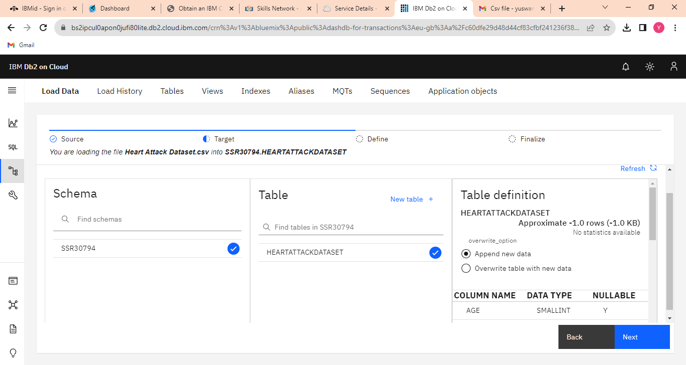

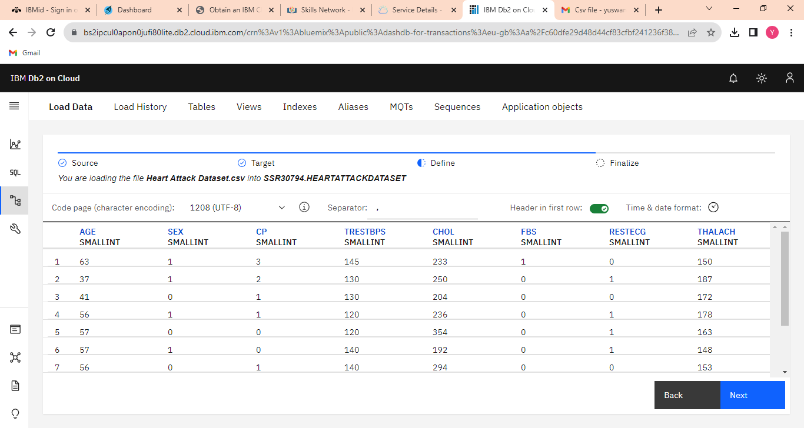

**STEP 9 : Here the dataset where created in the table-like row and column format. Finally, we can see the review settings.**

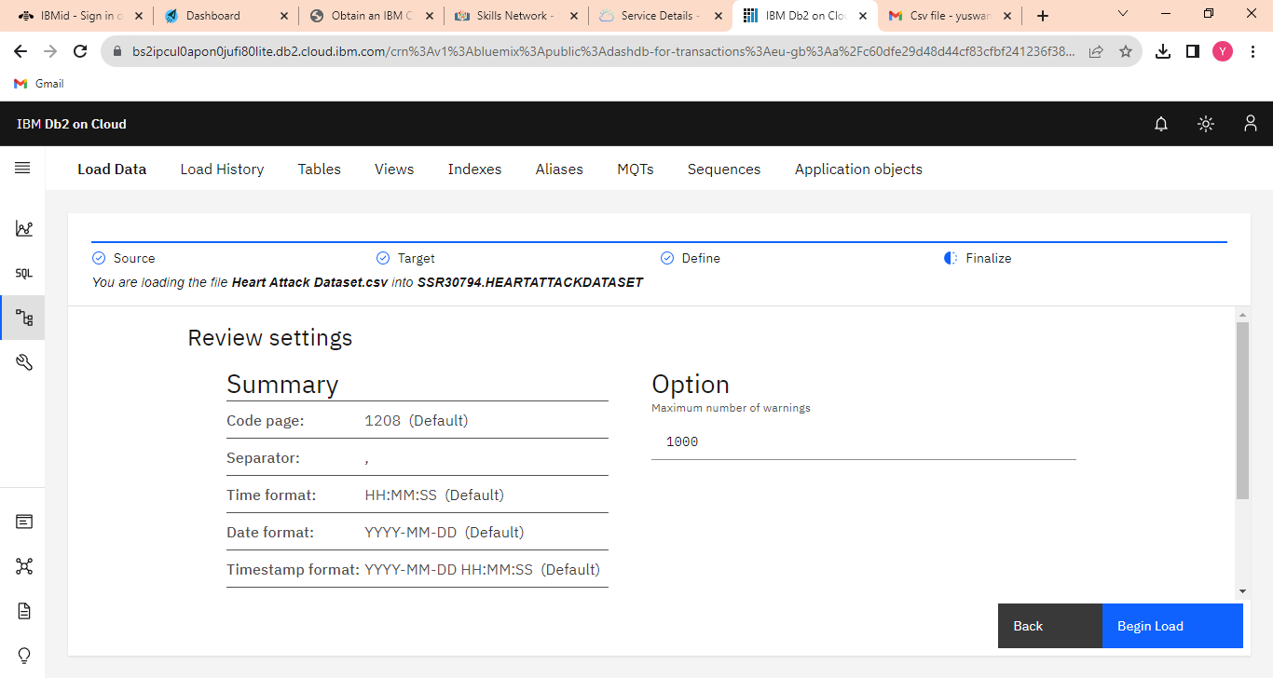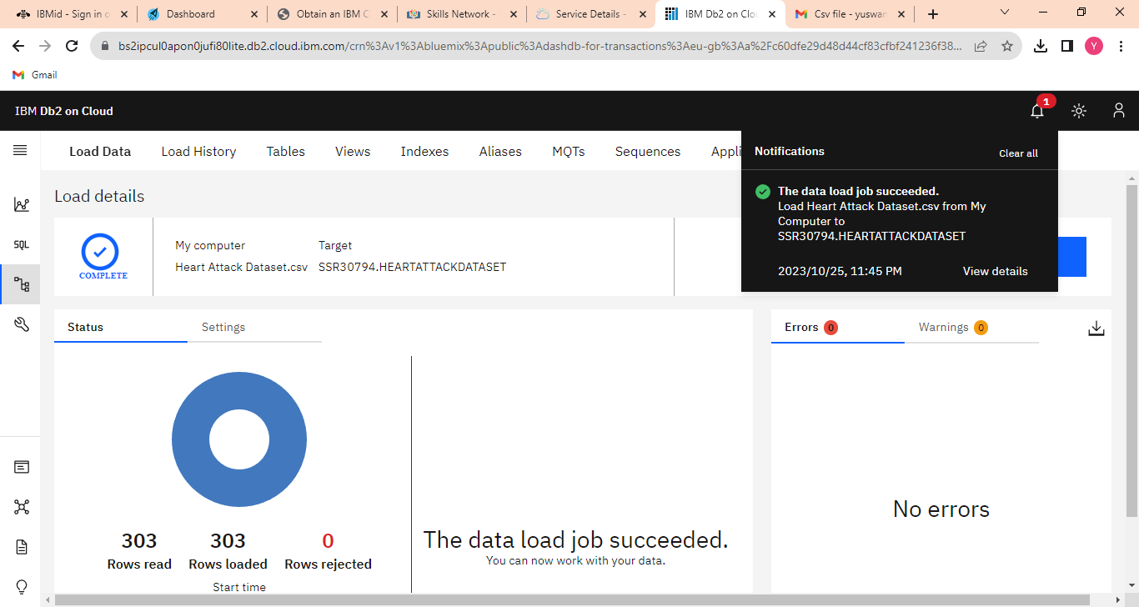

**In this 9th step, the data-loaded job is successfully completed.**

**Step 10 : Click the Run SQL option to write the query for the created dataset. To (get the output) click the run selected.**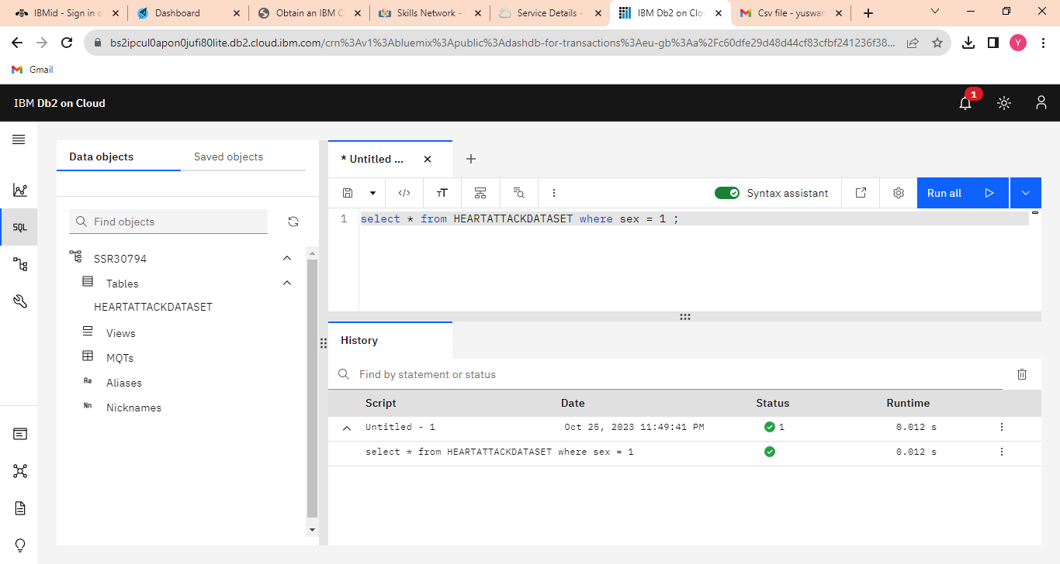

**Again go to the resource list to create the storage.**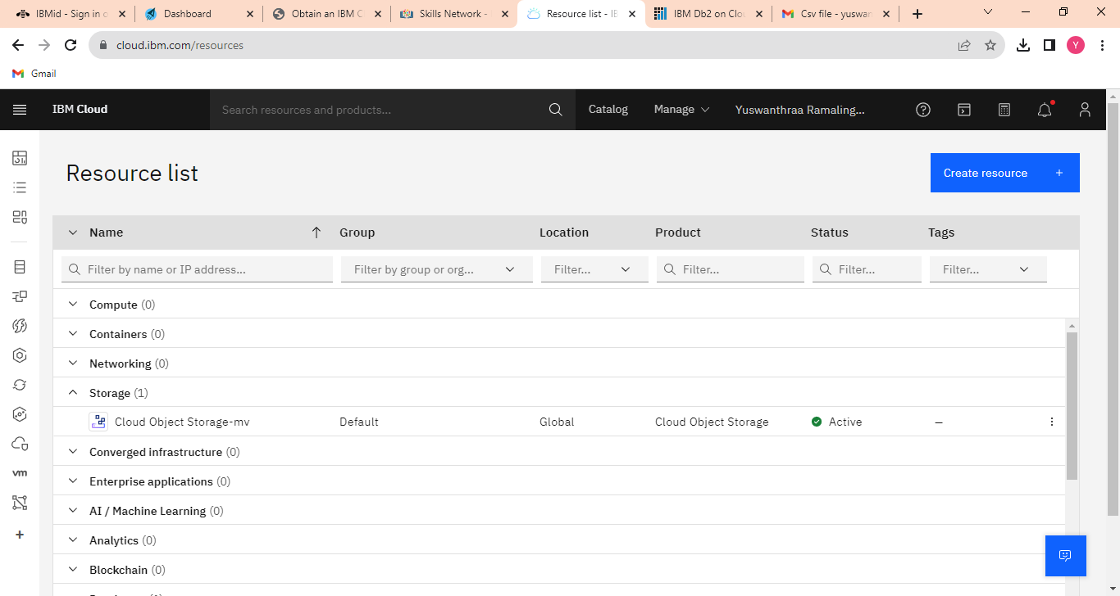

**Step 11: Click the object storage in the catalog, for creating the bucket.**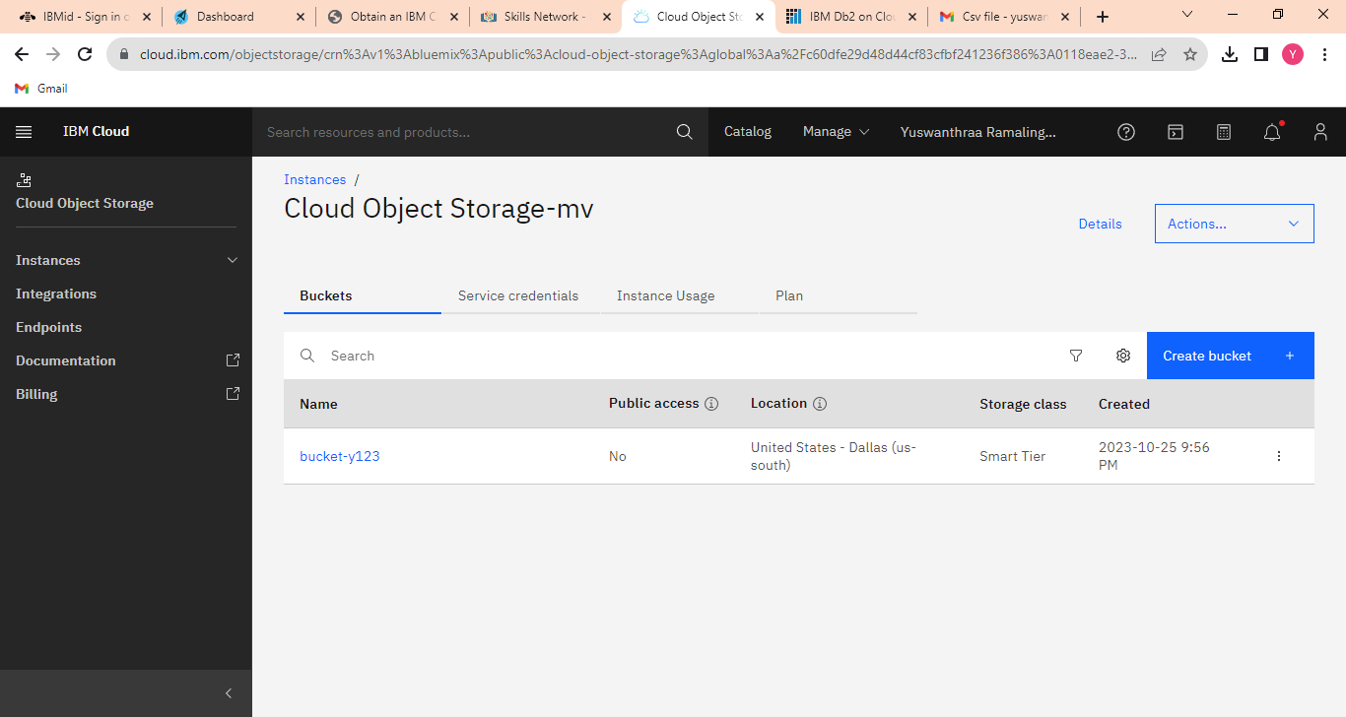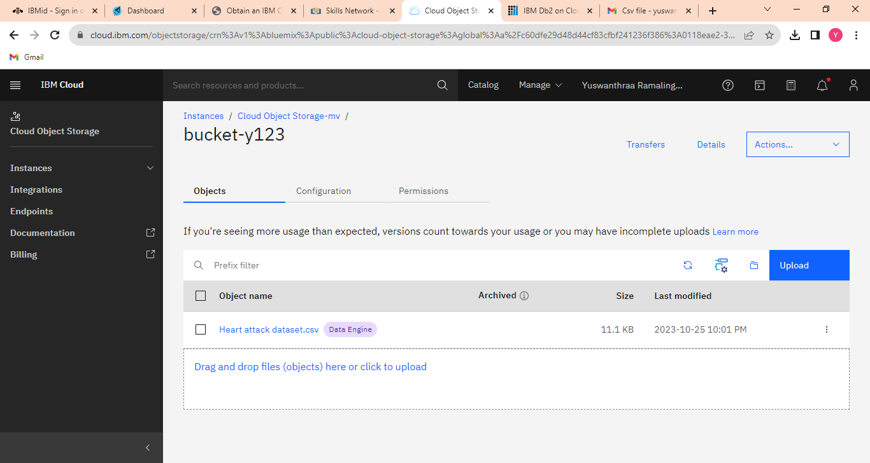

**Uploading the dataset in the bucket. We need to give the name for creating a new bucket. Configuration is knowing the bucket details. Permission is only for the user.**